Dr. Seuss At-Home Lesson Plan
During these crazy times, I thought it would be beneficial to create a week of learning surrounding Dr. Seuss. Dr. Seuss books are not only great tools to learn about rhyming and various other reading skills, but they are also fun and lighthearted, which is greatly needed at a time like this. The lesson plan this week will have some focus on developing rhyming skills, which is one of the TS GOLD objectives for this age group and is a pre-reading skill. Please meet your child at whatever level they are at; Some children may have no idea what rhyming is right now, and other children may be able to tell you two words that rhyme. Either level is just fine! The idea this week is to provide exposure to rhyming and enjoy the fun of Dr. Seuss books, so please keep that in mind if your child is not able to complete all of the activities successfully. Also, if you have Dr. Seuss books at home, I always recommend reading them with your child instead of watching the YouTube videos. Enjoy!

Monday:
Gross Motor and Literacy Activity of the Day: Before you read the story for the day, explain to your child that rhyming words are words that sound the same at the end. They can move and practice listening for the end sounds of words with this video: https://www.youtube.com/watch?v=ZQpMUs4EMv8 .

Literacy Activity of the Day: Listen to the book The Cat in the Hat by Dr. Seuss: https://www.youtube.com/watch?v=-LL62u6-OjY . Depending on your child’s interest in rhyming, you can either: 1) Enjoy the story and then at the end ask if your child knows a word that rhymes with ‘hat.’ Then, look at the cover of the book and find the word that rhymes with ‘hat.’ Point out that ‘cat’ and ‘hat’ sound the same at the end and that they also have letters that are the same in each word. OR 2) As you watch, ask your child to listen for rhyming words during the story and give a thumbs up when they hear words that rhyme. (There are a lot, so this may be something you only do at the start or end, or on a partial second reading of the story). This is an activity you can do with children throughout the week as you enjoy the Dr. Seuss books.

Cognitive/Writing/Fine Motor Activity of the Day: After listening to The Cat in the Hat, tell your child that you will work together to write a story about Thing One and Thing Two. Ask your child what they would do if Thing One or Thing Two came in their house. If they need help with the question, ask if they would play with them or try to catch them. Then ask, “What would you play,” or “How would you catch them?” Write down their answer while your child watches you write. (This is important because it helps children learn that their words are important and have meaning). After you write, ask your child to draw a picture to go with the story. Make sure you encourage them to use a three-point finger grip! If drawing is not something that interests your child at this time, ask them to act it out.

Math Activity of the Day: Refer to the cover of The Cat in the Hat. Point out to your child that the cat’s hat has a pattern: red, white, red, white. Then create a pattern with your child in a way that is most interesting to them. If your child needs to move, have them jump, clap, jump, clap, etc. If your child enjoys coloring, start a pattern with two colors of crayons and then hand them the crayons and have them finish the pattern on their own. If your child likes hands-on activities, use their toys (Ex. race car, animal, race car, animal) or some food items (Ex. Goldfish, Cheerio, Goldfish, Cheerio) to create a pattern.
Tuesday:
Gross Motor Activity of the Day: Exercise and practice rhyming with this song: https://www.youtube.com/watch?v=cSPmGPIyykU .

Literacy Activity of the Day: Watch this animated version of One Fish, Two Fish, Red Fish, Blue Fish by Dr. Seuss: https://www.youtube.com/watch?v=miXEcqI2W8s . This is a great version because it highlights the words as the story is being read, so the children can see that the words have meaning. If your child enjoyed the rhyming yesterday, continue pointing out the rhyming words from this story as well!

Art/ Fine Motor Activity of the Day: Use paint to make hand print fish or trace your child’s hand if you don’t have paint. Ask them to add a face on their own using a writing tool! Fine Motor/Math Extension Opportunity: If your child has good control when using a writing tool, teach your child how to draw a fish using an oval and triangle.
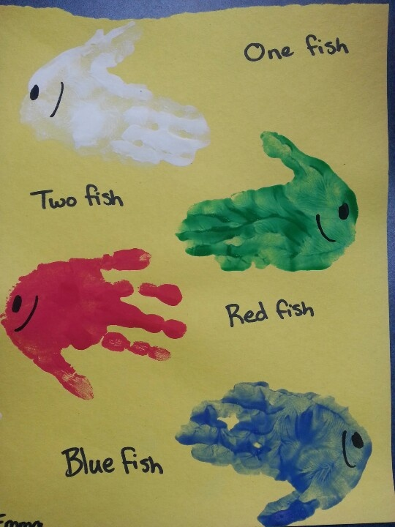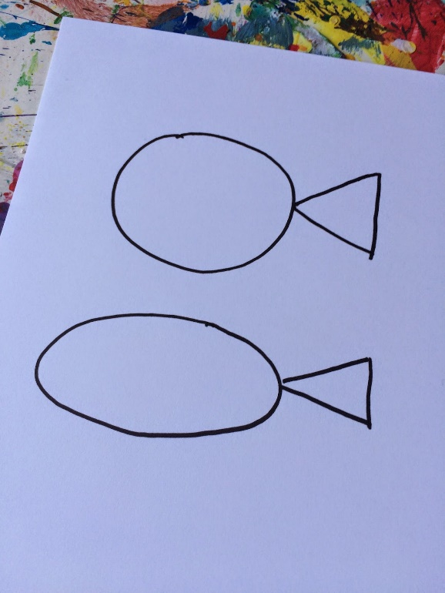

Music Activity of the Day/Brain Break: Enjoy listening to and acting out the “Goldfish Song” by Laurie Berkner : https://www.youtube.com/watch?v=Cg-wnQKRHTs .

Cognitive Activity of the Day: There are many opposite words in One Fish, Two Fish, Red Fish, Blue Fish. You can go back to the book and find some of them with your child and/or come up with some on your own to act out with your child (Ex. Have your child show you how they can make their body big and small. Have them jump high and crouch low. Have them show you short and long with their fingers.). You can also act out one pose and then have them show you the opposite. Also, take opportunities to point out opposites throughout the day (Ex. At dinner, talk about how the plate is full when you are serving the food. After your child is done eating, point out how the plate is now empty.) Here is a fun video on opposites to extend learning or provide ideas on some opposites: https://www.youtube.com/watch?v=HGeuA4iJ8vI .

Wednesday:
Literacy/ Nutrition Activity of the Day: Watch this read-aloud story of Green Eggs and Ham by Dr. Seuss: https://www.youtube.com/watch?v=jdotPwVJYzs . After the story, discuss with your child what foods they like and don’t like. Talk about how the character in the book discovered that he liked the food because he tried it! If you’d like, have a snack “taste test” and try different foods, discussing if you did or did not like the snack.
Cognitive Extension Opportunity: This can be a challenging activity for the age group, but if your child is showing awareness of rhyming and/or can identify letters, this would be a great adult-guided activity. If you happen to have various shades of green Easter eggs at home, you can create rhyming eggs and have your child put together the rhyming pairs as they listen to the story or after the story is finished to practice rhyming.
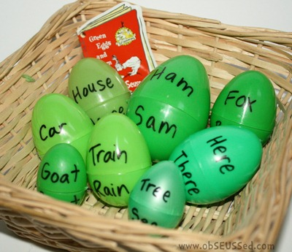
If you don’t have Easter eggs, you can also print this egg activity or draw your own to use while listening to the story: https://drive.google.com/file/d/12OYfkFi5tWI2P-XBydkq0ROZF-0_LIpe/view?usp=sharing .

Music and Movement Activity of the Day: Dance and practice rhyming with this song: https://www.youtube.com/watch?v=Bwy1PCkN6Kg . We use this song at school, and it’s a class favorite!

Science/Sensory Activity of the Day: If you have the ingredients, make some green “Oobleck” for your child to play and experiment with. Here is the recipe (scroll down-picture is on the next page):
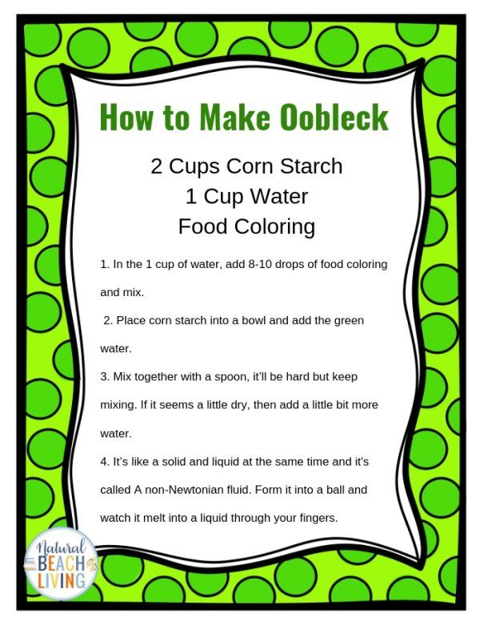
You may want to place some newspaper on the table first for easy cleanup. You can use this opportunity to talk about solids and liquids.

If you do not have the ingredients for Oobleck, allow your child to play with ice and water in a bowl. Ask them which is solid and which is liquid. After the ice melts, ask them if there is still a solid in the bowl.
Bonus Dr. Seuss Story Opportunity: This is a long story, but if your child is interested, here is Bartholomew and the Oobleck: https://www.youtube.com/watch?v=rdIeeeDVgcs&t=152s .
Thursday:
Literacy/Math Activity of the Day: Read Ten Apples up on Top by Dr. Seuss: https://www.youtube.com/watch?v=vdeqBUeEs-k . While listening to the story, you can stop reading or pause the story and ask your child to count the apples in the illustrations. After reading the story once, use blocks (or any items your child can stack if you do not have blocks) and read the book again; Have your child stack the blocks as you read. To extend this activity, have your child stack blocks to “measure” the height of different items around the house. (Ex. My stuffed bear is 6 blocks tall or the trash can is 15 blocks tall.)

Gross Motor/Language Activity of the Day: Have your child practice balancing a bean bag or small stuffed animal on their head as they walk. To make this more challenging and increase language skills, give your child commands to follow (Ex. Take three steps, freeze, walk around the kitchen chair, etc.).

Science and Gross Motor Activity of the Day: Ask your child if they know how apples grow; Discuss how they grow on trees. Here is a Blippi video that shows how apples get from the trees to the store: https://www.youtube.com/watch?v=Ff1ecYv24-E . After learning about apples, watch this yoga video to practice balance as you grow into a “tree” https://www.youtube.com/watch?v=a8BW7ktJCYA . The video also explains how seeds grow into plants.

Art/ Fine Motor Activity of the Day: Ask your child to draw a picture of themselves. Then have them finger paint or draw apples on top of their head in the drawing. When they are done, ask them to count how many apples they created. If drawing is too challenging for your child, just paint or draw with the color of their favorite apple, OR if you have apples at home, you can cut an apple down the middle from top to bottom and use one half for a snack and then use the other half as a stamp to paint with.
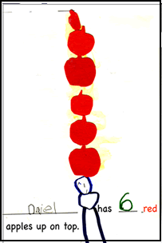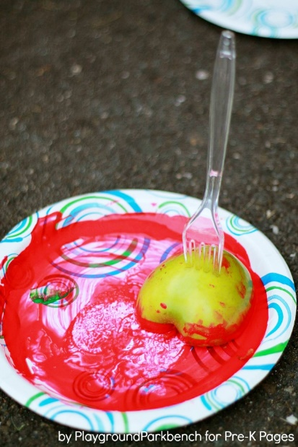
Friday:

Literacy/ Social Emotional Activity of the Day: Read the book My Many Colored Days by Dr. Seuss: https://www.youtube.com/watch?v=Lum83DLPXIw . After reading the book with your child, ask your child how they are feeling today. Ask them what color they think their feeling is and find it in the book. To talk about different feelings, this is a nice song to show your children: https://www.youtube.com/watch?v=-J7HcVLsCrY .

Music/Gross Motor Activity of the Day: Sing “If You’re Happy and You Know It” with your child and make up different movements to act out. Here is a song with some movements: https://www.youtube.com/watch?v=WiDRpk9li9I , or you can make up your own. If your child needs larger gross motor movements, go outside or in an open area in your house and add movements such as jump to the fridge, crawl like a cat, or gallop like a horse.

Math/Cognitive Activity of the Day: After reading the book, go on a “color hunt” with your child in their room. You can find and sort items into separate color piles. Then, after sorting the items, count how many items there are in each pile with one-to-one correspondence. If your child is enjoying the activity, ask them to take the items and sort them into like items (Ex. Clothes in one pile, toys in another pile, books in another, etc.).

Art/Literacy Activity of the Day: Provide your child with paint or crayons to make their own color creations. To develop letter identification skills, show your child how to paint or draw the first letter of the color you are using. Then have them trace your letter or practice on their own. If your child is ready for letter sounds, sound out the first letter of the word and see if your child can guess what letter starts the word based on the sound. (Ex. Say, “Puh, Puh, Pink. What letter makes the ‘puh’ sound?”)

