Nature Walk At-Home Lesson Plan
Monday:
Literacy/Science Activity of the Day: Listen to Ms. Jillian read The Bear Went Over the Mountain by Iza Trapani: https://www.youtube.com/watch?v=tryZvcaZ4Rg . Help your child recognize the changing seasons in the illustrations as you listen to the story.

Daily Walk and Science Activity of the Day: After listening to the book, go on a “Five Senses” walk. Listen for what sounds you hear (birds, cars, dogs barking, etc.), stop and feel rocks or tree bark, smell pine trees, ask your child what they see, and taste a snack that you pack to enjoy on your walk. We use this model when we go on nature walks at school, and the children greatly enjoy it! Also, even though other activities will be the focus of other nature walks during the week, you can point out things you hear, see, smell, or feel on any of your walks (bring a snack to use the sense of “taste” on any of your walks). Also, it may be fun to take walks before and after rain. Talk to your child about what is different from each walk (Ex. Feel squishy mud, see water puddles, etc.)

Cognitive/Writing/Fine Motor Activity of the Day: After your walk, write a story about your walk with your child. Tell them that you will remember the walk together and that you will write down the words about your walk (This is important so that the children understand that words have meaning). Start the story with, “One day Mommy and Jane went on a walk.” Then, write a sentence for each of the five senses. Increase cognitive recall skills by asking your child questions about the walk. (Ex. “What did we see on our walk today?”) Write their responses while adding to the story. (Ex. “They saw…,” “They heard…,” etc.) Add any other details your child shares as well. (Ex. “Jane heard a bird chirp and she was curious where the sound was coming from.”) After writing the story, ask your child to draw a picture of their favorite part of the walk. If drawing is challenging for your child or if they have a hard time thinking about their favorite part, ask them to draw something simple, such as the shape of an item they found. (Ex. Kickball, rock, tree, etc.).

Art/Science Activity of the Day: Make sound shakers. Get creative with the materials you have in your house; You can have your child color a paper plate and then place beans inside, fold the plate over, and tape it all shut. You can reuse Easter eggs and put rice inside. Use an old plastic container and put small rocks inside. Allow your child to decorate their shakers with paint or stickers if possible.
Cognitive/Science Activity Extension: Make a few different shakers with different materials (including items that don’t make a lot of noise as well as items that make a good shake sound allows for more comparison opportunities). Ask your child which of the five senses they are using to listen to the shakers. Then discuss which shaker is loudest and which one has the softest sound. Ask them why they think one shaker is louder or quieter than the others.
Tuesday:
Literacy/Science Activity of the Day: Listen to The Thing About Spring by Daniel Kirk: https://www.youtube.com/watch?v=sLkK98zuw0c . After the story, have your child answer the question, “What is your favorite season?” that is asked at the end of the video. Your child may remember the seasons that were shown in the book from yesterday. If your child does not know much about the seasons, listen to this short non-fiction book so they can learn more: https://www.youtube.com/watch?v=ptBop3HCvxM .

Daily Walk and Science Activity: After reading the book of the day, discuss the signs of Spring. Go on a nature walk and focus on finding the signs of Spring (Ex. Birds chirping, tulip buds growing in a neighbor’s front yard, wearing a lighter jacket because the weather is warmer, plants growing in backyard, rain instead of snow, etc). Also, enjoy looking at the different kinds of trees. Look to see if buds are growing on some trees. Discuss why some trees don’t have leaves right now and why some trees, like pine trees, still have green on them. If you need more information to help describe coniferous and deciduous trees, watch this short video: https://www.youtube.com/watch?v=-lc3vLCKdmg Math/Fine Motor Extension: Bring a notebook and record the number of birds or rabbits you see (or an item you are seeing multiples of that they are excited to look for). Have your child make tally marks in the notebook and then count the marks when you return to the house. Show your child how to write the corresponding numeral. Then encourage them to write the numeral on their own or trace the numeral you created.

Art/ Fine Motor Activity of the Day: Enjoy painting outside. If you have the ingredients, create eco-friendly outdoor paint (Mix 1/4 cup corn starch, 1/4 cold water, and about 8 drops food coloring in a bowl) and allow your child to use brushes to paint on the sidewalks with the paint. If you do not have the ingredients, set up an area for your child to paint or draw outside. Ask your child if they can paint what they see outside.

Gross Motor Activity of the Day: Move to the “Springtime Dance” https://www.youtube.com/watch?v=udrIY0nts-E

Wednesday: Happy Earth Day!
Literacy/ Cognitive Activity of the Day: Listen to The Earth Book by Todd Parr: https://www.youtube.com/watch?v=lpEc5nHqO2c . Discuss some of the actions in the book that could be relevant to your family. Social Emotional Extension: Ask your child to think about one thing they could commit to do today to help the Earth. Bonus Book: The children love Curious George books, so here is an Earth Day book, Curious George Plants a Tree by Margaret and H.A. Rey: https://www.youtube.com/watch?v=3XWm7xdAJzw

Gross Motor Activity of the Day: Move to this Earth Day song: https://www.youtube.com/watch?v=YgdL8xEKGnc

Daily Walk and Language/Math Activity of the Day: As you go on a walk today, tell your child that they will be playing a listening game. Throughout the walk, give your child commands, such as “Go around the puddle,” “Jump over the rock,” “Walk slowly from the tree to the big rock,” “Run fast from the deck to the bush,” etc.).” Not only does this activity help children process language, it helps children gain new vocabulary words, develop an understanding of positional language, and increases impulse control.

Music/Science Activity of the Day: Enjoy listening to this Earth Day song: https://www.youtube.com/watch?v=lJToF8D9bdU . Continue discussions on how you can help the planet if you’d like!

Music/ Art Activity of the Day: Watch this short song on the “Three Rs” that help our Earth: https://www.youtube.com/watch?v=jsYmorct2H4 . Then, reuse items you would normally throw away to paint! Items such as wine corks, milk caps, old keys, etc. can make painting more interesting and fun.

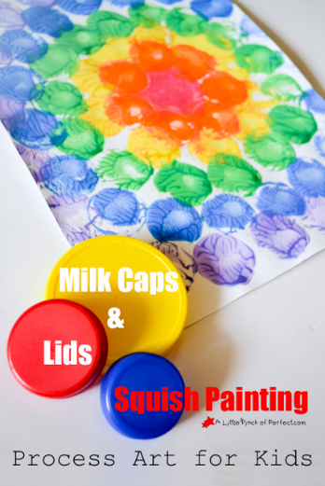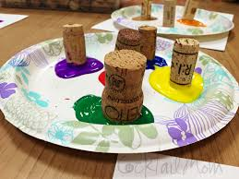

Bonus Dr. Seuss Story Opportunity: Listen to The Lorax by Dr. Seuss: https://www.youtube.com/watch?v=EdWesdMfyd4 . Discuss what happened when the characters in the story cut down all the trees. Ask your child what they would have done and how we can take care of our environment now.
Thursday:
Literacy Activity of the Day: Listen to Going on a Nature Hunt by Steve Metzger: https://www.youtube.com/watch?v=SYHotI8HETc . Discuss what items are helpful to bring on a long hike. Discuss what items you will be bringing on your walk today.

Gross Motor Activity of the Day: Stretch with this “Outside in Woods” yoga video: https://www.youtube.com/watch?v=L8eMSTZ1LbI

Daily Walk and Literacy/Science Activity of the Day: Today while you are walking, collect small pebbles and rocks in a bag or sand bucket; These items will be used for sorting, counting, and ordering later. Also, in another grocery bag or sand bucket, collect items that can be glued on a nature collage. Items such as small pieces of bark, weeds or grasses, pine needles, etc. are good for this. While you are walking and collecting, stop and ask your child to write their name in the dirt with a stick. Ask your child if they can think of other ways to make their name outside.

Math Activity of the Day: Use items collected on your walk to sort, count, and order. First start by sorting the rocks you found. You can place them in categories such as small and large, smooth and rough, black and white, etc. After sorting, ask your child to count how many are in each group. Then ask your child which group has more and which has less. At the end, ask your child to place the rocks in order from smallest to largest. If you would like to extend this activity to add literacy, add words to the sorting piles like the picture below.
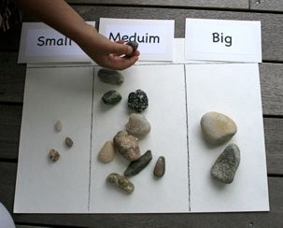
Art and Sensory Activity of the Day: Use the items collected on your walk and glue or tape to create a nature collage.
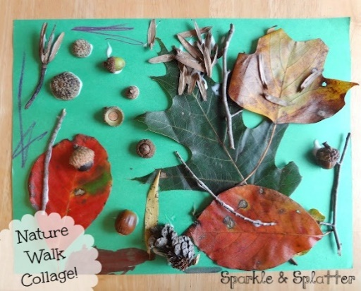
Friday:
Literacy Activity of the Day: Listen to The Busy Tree by Jennifer Ward: https://www.youtube.com/watch?v=3XWm7xdAJzw. After the book, ask your child about the ways trees are helpful to animals and people. Also, if you are working on rhyming with your child, ask your child if they heard rhyming words while listening to the story. Listen to the story again and find all the rhyming words (pausing the story for discussion could be helpful to allow for thinking time).

Art Activity of the Day: Make your own binoculars to use on the nature walk. Use two toilet paper rolls, a stapler or tape, string, yarn, or ribbon, and any decorating materials (markers, paint, stickers, tinfoil, etc.) to create the binoculars. Here is a 1 minute video for quick instructions on how to make the binoculars: https://www.youtube.com/watch?v=iM-oM8fPduo . I recommend hole punching the sides of the toilet paper rolls and tying the string on rather than taping it if you have a hole punch.

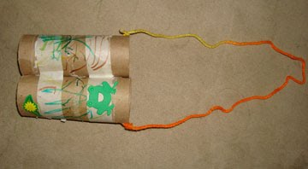

Daily Walk and Math Activity of the Day: Before going on a walk, prepare a “Shape Necklace” for your child. Draw small basic shapes (square, circle, triangle, circle, oval, diamond) on construction paper (or any paper if you don’t have construction paper), cut them out, hole-punch them at the top, and string yarn through the shapes (make the yarn long enough for your child to stretch the necklace out to hold up and match to a shape they have found). If you have a straw, cut it into ¾ inch pieces and then place pieces in between shapes to keep them separate (Beads could also be used). Help your child identify the shapes and explain that they will be using the necklace to find shapes outside. If you need some inspiration on how to find shapes in nature, watch this short video: https://www.youtube.com/watch?v=_TTB83JkOB4 . While on your walk, your child can use their binoculars to search for shapes. If they need help or you would like to extend this activity, play “I-Spy.” Say, “I spy a white rectangle,” or, “I spy a red circle.” After your child thinks they have found the shape, have them hold up the shape on their necklace that they think matches. Ask them if it matches after they look. To extend cognitive thinking and knowledge of shapes, ask them how they know. Responses could be, “Because they both have three sides,’’ or, “Because they are round.”
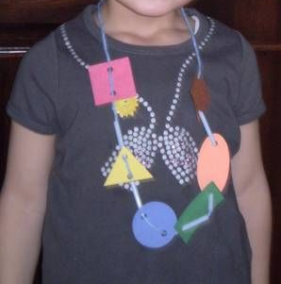

Literacy Activity of the Day: Use sidewalk chalk to make letters on the sidewalk. Ask your child to use nature items to make the letters you drew. Rocks or sticks would be perfect for creating the letters. If you do not have chalk or the weather is not nice outside, you can give your child a piece of paper with a letter and a small tray of nature items to place on the letter or glue down.

