At-Home Ideas for the Week of May 4th to May 8th
Monday:

Literacy/Science Activity of the Day: Ask your child if they know where they can go to see dinosaur bones. Listen to The Berenstain Bears: Dinosaur Dig by Jan and Mike Berenstain: https://www.youtube.com/watch?v=TSzxovZXzPU. After the book, discuss museums. If your child would like to know more about dinosaur skeletons in the museums, listen to Dinosaur Bones by Bob Barner: https://www.youtube.com/watch?v=XPvthRr31os&t=74s .

Gross Motor Activity of the Day: Pretend to be a dinosaur with the Laurie Berkner song, “We are the Dinosaurs”: https://www.youtube.com/watch?v=vPrmY7labLA .

Art/Fine Motor Activity of the Day: Use playdough or aluminum foil to create dinosaurs or dinosaur bones. Your child may need help learning how to roll balls for the body or longer pieces to make legs. Engage cognitive skills by asking, “What shape could we use to make the head?”

Math/Gross Motor Activity of the Day: Play a “dinosaur traffic jam” game. Get creative with this game to build your child’s understanding of positional words and help them learn patterns and respond to specific language. Begin the game by telling your child that you will pretend that you are both in cars and need to drive to the store. Show your child how to pretend to make a steering wheel and walk around like you are “driving.” Then tell them that there is a traffic jam because dinosaurs are blocking the road! This is where you get creative; Tell your child that maybe you both could try a pattern of honks to get him to move. Teach two different honk sounds and then create a pattern to repeat. Then, when you decide the road becomes clear, tell your child that you will give directions for driving so they can get to the store safely. Give your child commands like, “Go around the table” or “Go over the couch pillow,” to increase language skills.
Tuesday:

Literacy/Cognitive Activity of the Day: Ask your child if they remember the name of the people who find dinosaur bones. Many of them had mastered saying the word, “Paleontologist,” during the school unit, so they may remember. Then ask your child what tools a Paleontologist may need to excavate (Provide this new vocabulary word and then clarify by saying, “or dig out”) fossils or dinosaur bones. Make a list of what your child says, and then see if you can find the tools they came up with in the story. Listen to Ms. Jillian discuss fossils and read Curious George’s Dinosaur Discovery by Margret and H.A. Rey: https://www.youtube.com/watch?v=jphKNX51Mro&t=3s .

Outdoor Sensory/Literacy/Cognitive Activity of the Day: Provide your child with a tray of dirt (or mud if you don’t mind getting dirty!) and toy dinosaurs outside and ask your child to use a toy dinosaur to write the letters of their name in the mud (Let them experiment with ways to use the dinosaur for this task). After writing letters in the dirt, then ask your child to find items for a “dinosaur playground.” Talk to your child about what items they found and why they chose those certain items. Ask your child what they like to do on a playground and what items they can use to represent those items (Ex. Stick for a slide, rock for a climbing wall, etc.) After making the playground, enjoying playing with the dinosaurs in the playground. Play with your child and expand language skills by saying phrases like, “My dinosaur is going under the bridge,” or “My dinosaur is going around the trees.”

Math Activity of the Day: Write numerals on a paper and then have your children place that amount of toy dinosaurs (or animals or cars) on the page.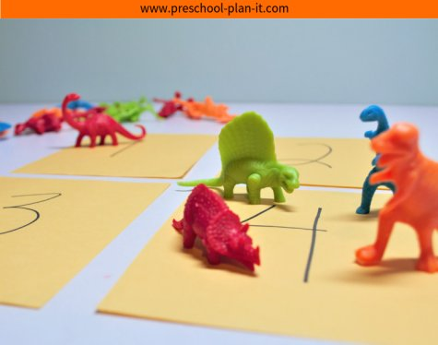

Gross Motor Activity of the Day: Enjoy this 20-minute dinosaur yoga video: https://www.youtube.com/watch?v=rnlDBKD2S78 .

Wednesday:

Literacy/ Math Activity of the Day: Begin today with the “Days of the Week” song. Tell your child to jump up on the day of the week that it is. (Pointing to the days on a calendar while the song plays could help your child know when to jump. I usually tell them to get ready when they see me point to the day before the one they need to jump up for.) Here is the song: https://www.youtube.com/watch?v=oKqAblcwFOA . After the song, listen to Ms. Jillian read Dinosaur Days by Linda Manning: https://www.youtube.com/watch?v=6OmsYJkkgOk&t=7s. After the story ask your child which day their favorite dinosaur arrived on. Then, to further extend learning from the book, write down a numeral that was in the book on a small piece of paper and ask your child to identify the numeral. If your child is enjoying learning about numerals, hide the sheets of paper that have the numerals on them in the house, and have them try to find the numerals just like they had to do in the book. Ask them to tell you what numerals they found.

Gross Motor Activity of the Day: Get moving with the “Dinosaur Stomp”: https://www.youtube.com/watch?v=Imhi98dHa5w .

Cognitive Activity of the Day: Play a dinosaur “mirror game” with your child. Tell your child that you are going to act out a dinosaur movement and that you want them to copy the movement. Then, allow your child to act out a pose for you to copy. This game will help your child learn to attend and engage.

Music/Math Activity of the Day: Enjoy listening to “Ten Little Dinosaurs”: https://www.youtube.com/watch?v=TjmGTbNLj6Q . Afterwards, practice counting ten items with one-to-one correspondence.

Art Activity of the Day: Paint with plastic toy dinosaurs. If you don’t have any dinosaurs, use other animals or cars for a different painting experience. (See Picture Below)
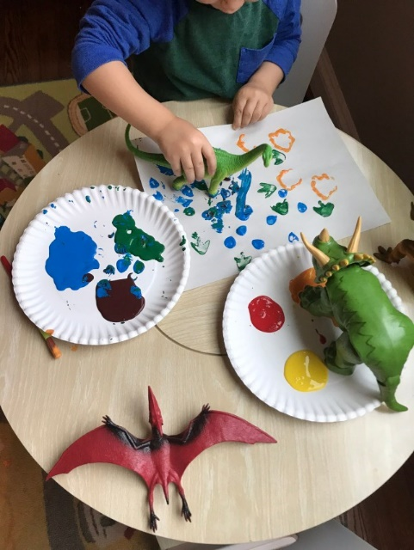
https://www.sunshineandchaos.com/2019/02/25/dinosaur-tracks-painting-activity/

Thursday:

Literacy/Cognitive Activity of the Day: Enjoy listening to Too Many Dinosaurs by Mercer Mayer: https://www.youtube.com/watch?v=2xImqWFNlA8 . At the end, ask your child what they think will happen next.

Gross Motor/Art Activity of the Day: Print and create a dinosaur movement cube (The link will provide instructions and options for printing): https://www.creativelittleexplorers.com/roll-dinosaur-movement-game/
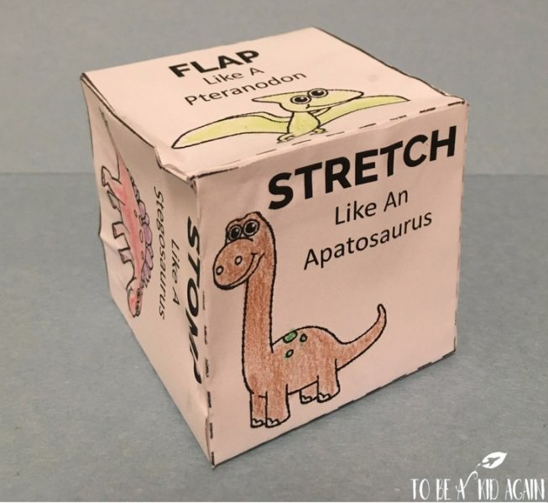
If you do not have a printer, you can just give your child the commands to act out such as, “Stomp like a T-Rex.” (Click on the link above the picture to see the other commands).

Math Activity of the Day: Practice counting with one-to-one correspondence while pretending to “feed” toy dinosaurs (or other toy animals if you do not have a dinosaur). Gather a few beans, pieces of rice, or small leaves or sticks from outside (anything your child can count while pretending to feed a dinosaur). Start by saying, “This dinosaur wants to eat 6 beans. Can you feed him the correct amount?” Watch your child count with one-to-one correspondence and make sure they point to each item as they count.

Music Activity of the Day: Enjoy these StoryBot songs: https://www.youtube.com/watch?v=4H0q9x3qVmU .

Sensory/Science Activity of the Day: Create frozen dinosaur eggs for a science and sensory experiment. Stretch out a small balloon, place a small dinosaur inside, and then freeze the balloons. When solid, cut off the balloon and then provide your child with warm water to melt the ice with. If you have them, provide your child with a dropper or small measuring cup for your child to experiment melting the ice with. (For more clarification on directions, visit this link: https://littlebinsforlittlehands.com/frozen-dinosaur-eggs-ice-excavation-sensory-play/?jwsource=cl . This is a great activity to do outside on a warm day! Also, if you do not have balloons or dinosaurs, this is still fun to do with just regular ice!
Friday:

Literacy/Cognitive Activity of the Day: Listen to Ms. Jillian read The Dinosaur by Anna Milbourne: https://www.youtube.com/watch?v=lO3NteddAHY . Discuss the difference between herbivores and carnivores. Then, listen to Dinosaur Roar by Paul and Henrietta Stickland: https://www.youtube.com/watch?v=5MMiiXlFNZA . Afterwards, ask your child if they heard opposites in the story. Review or listen to the book again and point out the opposites.

Gross Motor/Math Activity of the Day: Play a “compare and measure” game to help build math skills and practice opposites. Tell your child that they will pretend to be a dinosaur while you give them a direction. Chant these words before giving the command:
Busy dinosaur, Busy dinosaur,
Stomp around the world.
Busy dinosaur, Busy dinosaur,
Touch Something (taller than you) (Get creative with other commands like, “Touch something smaller than the cat,” or “the same size as this spoon,” etc.)

Music Activity of the Day: Enjoy listening to a Blippi dinosaur song: https://www.youtube.com/watch?v=hpVoTUmZIZs

Writing/Fine Motor/Math Activity of the Day: After listening to the Blippi song, ask your child what their favorite dinosaur is. Then, tell them that you will write a story about the dinosaur together. Help your child develop ideas by asking, “What is the first thing your dinosaur did when he woke up in the morning?” Continue the story with three questions that involve the language, “first,” “second,” and “third.” Write down the words as your child speaks so they can see that their words have meaning. After writing the story, ask your child to draw a picture of their favorite dinosaur to go with the story. Encourage your child to use a three-point finger grip while using a writing tool. If drawing becomes too frustrating for your child, ask them to just draw with the color they want their dinosaur to be.

Art Activity of the Day: If you have the ingredients, create “salt dough fossils.” Make the dough with: 2 cups flour (Use wheat flour to make a darker dough that looks more natural), 1 cup salt, and 1/2 cup warm water. After the dough is made, your child can make “fossils” by placing plastic dinosaurs on their sides in the dough or by walking their dinosaurs through the dough to leave tracks.
https://www.makelifelovely.com/diy-dinosaur-fossils-with-salt-dough/

